Engineering Cycle Teacher’s guide

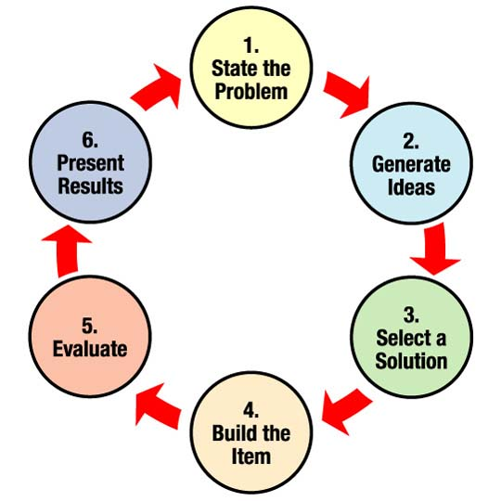

(Adapted from teachengineering and Engineering Is Elementary.)
Safer highways. Cool phone apps. Green buildings. Thrilling roller coasters. What do all these things have in common? All bear the stamp of engineering design – a process of brainstorming, building, testing, and refining to create a product, service, or system within time or resource limits.
Some people equate design with veneer or decoration. To Apple founder Steve Jobs, however, it was “the fundamental soul of a human-made creation.” For engineers, the design process is a series of steps that helps teams frame and solve complex problems. Anyone can do it!

ASK
- What is the Challenge?
- Are there limitations or requirements?
- What do we know already?
IMAGINE
- Brainstorm possible solutions
- Consider Design Options
PLAN
- Choose the best design
- Draw a picture
- Identify appropriate materials
CREATE
- Build solution based on plan
- Test it out
IMPROVE
- Study test results
- Modify design to make it better
- Test it out again
To figure out how to build something, engineering teams gather information and conduct research to understand the needs and challenges to be addressed. What is problem. What do we want to accomplish? What are the project’s requirements and limitations? Who’s the customer? Then they brainstorm many imaginative possible solutions, even wild and crazy ideas, selecting the most promising one for their design. The process includes drawings, analyzing and deciding on what materials and technologies to use, and creating many prototypes that get improved upon until the product design is good enough to meet their needs. The process includes figuring out what data to collect to be sure the design works well, and assigning team tasks.
Tips for incorporating engineering design in the classroom 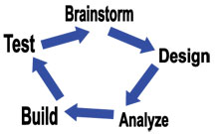
A key theme of the engineering design process is teamwork. Since students design in small groups, encourage them use the steps of the engineering design process. How will they work well together, listening to and respecting all ideas in the brainstorming session, reserving any judgment until a decision is made? Even then, make the decision-making process as democratic as possible, with all opinions being heard.
Once a teamwork base is established, build upon that with a creative design. If a team of students is excited about their idea, they can come up with some fun methods for improving or extending the original idea. Reinforce with them that the end goal is a design solution that is a seamless blend of creativity and utility. And remember, there are no bad ideas!
Source: http://teachers.egfi-k12.org/design-process/

